CHM 107, Quiz 1 Name __________________________________________

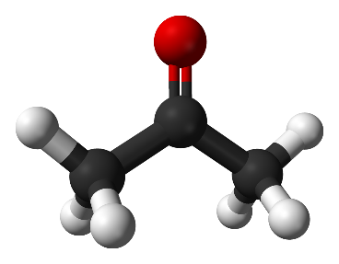
We’re going to be looking at how much energy is required to bring a 125 g sample of acetone (C₃H₆O) from 100.0 K to 450.0 K. Acetone is commonly found in nail polish remover and other solvents, is quite volatile, and flammable. It is the simplest ketone, has a structure shown to the right, and a MW of 58.0791 g/mol. Use the following steps to get to your answer. You MUST show your work to receive any credit. The following physical data for acetone may be useful. This quiz mainly draws from chapter 11, slides 47 onward. See announcement for due date.

ΔH_{vap} = 29.1 kJ/mol @ bp ΔH_{fus} = 5.72 kJ/mol @ mp
T_{melting} = 178.7 K T_{boiling} = 329.3 K
C_{gas} = 1.29 J/g°C C_{liquid} = 2.16 J/g°C C_{solid} = 1.65 J/g°C
Source: https://webbook.nist.gov/cgi/cbook.cgi?Name=acetone&Units=SI&cTG=on&cTP=on

1) Determine number of moles the sample contains. ___________________moles

2) Starting at 100.0 K, how much energy must be added to heat the ___________J
solid to reach its melting point?

3) How much energy must be added to convert the solid to a liquid? ___________J

4) How much energy must be added to bring the liquid from its ___________J
melting point to its boiling point?

5) How much energy must be added to convert the liquid to a gas? ___________J

6) How much energy must be added to heat the gas to 450.0 K? ___________J

7) What is the total amount of energy, in kJ, needed to go from ___________kJ
100.0 K to 450.0 K? Round to 3 sig figs.

8) What is the ΔH_{sub} (heat of sublimation)? ___________kJ/mol

9) We are told that acetone is a volatile compound. Given the _____________atm
normal boiling point and ΔH_{vap}, what is the vapor pressure
of acetone at room temperature (23 °C or 296 K) using the
Clausius–Clapeyron equation?

